26_bzone_parking.csv

April 21, 2026

Definition of the Input File

This file contains seven attributes. Six are explained in the VisionEval Documentation. (https://visioneval.github.io/docs/model-inputs.html). The first three refer to free parking spaces for residents of single family dwellings, multifamily dwellings, and group quarters residents.

The next three attributes refer to
- the proportion of workers who pay for parking overall
- the proportion of non-work trips that require payment for parking
- the proportion of workers who pay for parking “in a cash-out-buy-back program”

The last attribute is the average daily cost for long-term parking—that is, if a tourist would pay $10 for parking for a single day but a commuter could purchase parking on a monthly basis for $100, then the commuter’s average daily cost would be $100/(20 work days in a month) = about $5.

For example, consider 3 bzones: 515400010001 (downtown Charlottesville), 510030107021 (a suburban area near Route 29 in Albemarle County), and 510030110004 (a rural residential area in Albemarle County).

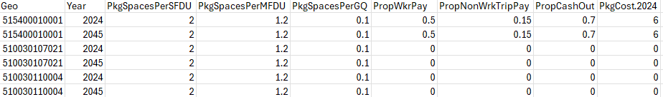

For all three bzones, the data suggest the number of fee parking spaces per single family dwelling unit is 2, per multifamily dwelling unit it is 1.2, and 0.1 for group quarters such as dormitories. In the most urban bzone, about 50% of workers pay for parking (compared to 15% for non-work trips), with most persons in a cash-out buy back program still choosing to pay for parking (70%). In that same urban zone, a monthly parker pays $6 per day. In the two less-urbanized zones, all parking is free and thus the last four attributes are all zero.

Possible Scenario

The document Task 7.2 Simplified Scenario Development guide, available at A Playbook for Simplified Approaches for Creating Scenarios in VisionEval devotes a substantial amount of attention to this topic, with the word “parking” appearing 60 times. Three scenarios suggested therein are: (1) examine how modes of travel change from auto to transit, bike, and walk as the parking pricing is raised; (2) determine if an increase in parking pricing in bzone X causes greater shopping to bzone Y with free parking, and (3) compare the imapct of work parking prices and shopping parking prices on global outputs such as VMT and emissions.

Method Used for Virginia

For the first three attributes, the same value was used for all Bzones in Virginia, where the number of free parking spaces for residents of single-family dwellings, multifamily dwellings, and group quarters residents was set at 2, 1.2, and 0.10. All three values may be adjusted by the analyst:
  - For single family detached dwelling units, the availability of street parking and driveways could influence this number in high density areas.
  - The free parking for multifamily dwellings should vary by location as a rough function of density, so this may be adjusted by the analyst.
  - For group quarters parking, using the example of college dormitories, the amount of free parking tends to be low, and the team selected a low percentage of 0.10. This value may be adjusted.

For the fourth and fifth attributes, the team indicated that for bzones with free parking, 0% of workers and 0% of non-work trips entailed payment for parking. For bzones with paid parking, the research team arbitrarily set the work trip percentage at 50%. This 50% may be adjusted, of course, with local information. Note the 5th attribute (PropNonWrkTripPay) is not given in the VisionEval documentation but rather described at https://github.com/gregorbj/OregonDOT-VisionEval/blob/master/documents/drafts/Non-Work_Parking_Mods.md?plain=1. If this attribute is excluded, then it is assumed that “non-work travel to a Bzone pays for parking if a parking cost has been assigned to a Bzone.” For bzones with paid parking, the research team set this to 15% to reflect that nonwork trips are more discretionary, but a different percentage could be chosen (although logically that percentage should be lower than that of PropWkrPay).

For the 6th attribute, the team indicated that 70% (most) of workers pay for parking in a cash-out-buy-back program for areas where there is a parking charge and 0% otherwise. The 70% may be adjusted in areas where information on travel demand management programs is available. If the TDM programs change behavior substantially, then presumably the 70% becomes a much lower number; if a TDM program has no impact whatsoever, then presumably the 70% becomes 100%.

For the last attribute—the average daily cost for long-term parking—the team hypothesized that this cost would have some relationship with a data element available from the Smart Location database: attribute D1D, which is the “gross activity density” (defined by EPA as the sum of employment plus households) on unprotected land. Gross activity densities for two areas in Northern Virginia—Ballston (left) and North Springfield (right) are shown in Figure 1. Then, monthly parking prices were obtained for these two areas from Spothero on April 21, 2026 for the month beginning May 1, 2026. For Ballston, a wide range of prices was chosen, but the research team selected the lowest one ($124) and for North Springfield, no parking was shown (which was to be expected as there is ample parking along the street free of charge).

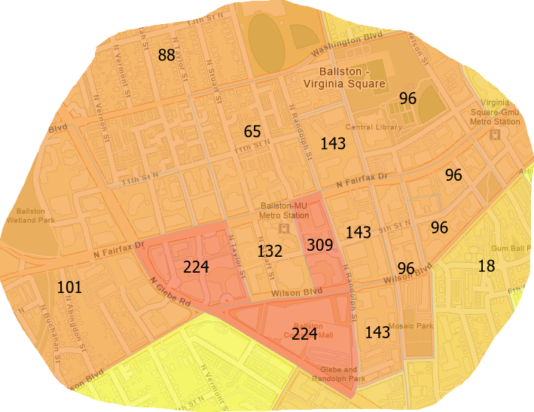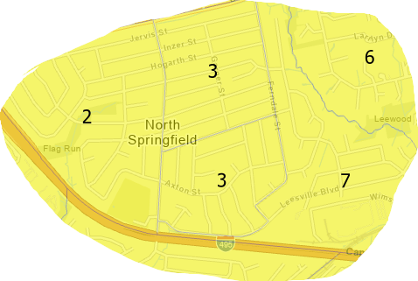
Figure 1. Gross Activity Density for Ballston (left) and North Springfield (right)

A few other locations provided additional data points. These were Charlottesville (lowest monthly price of $120), Alexandria (lowest monthly price of $180), Tysons Corner (lowest monthly price of $90), Norfolk near Granby Street (lowest monthly price of $77), and Richmond (lowest monthly price of $123 near the state Capitol). Table 1 shows a rough view of these monthly prices, ranges of gross activity densities near these locations, and an estimated daily price based on dividing the monthly price by 20 working days and rounding to the nearest dollar.

Table 1. Sampled Monthly Parking Prices and Gross Activity Densities
Location | Monthly price (Daily price) | Gross Activity Density
Alexandria (near Old Town) | $180 ($9) | 106
Ballston | $124 ($6) | 224
Richmond (near State Capitol) | $123 ($6) | 90
Charlottesville  (near the Downtown Mall) | $120 ($6) | 63
Virginia Beach | $100 ($5) | 29
Tysons Corner | $90 ($5) | 93
Norfolk (near Granby Street) | $77 ($4) | 21
North Springfield | $0 ($0) | 3

Table 1 is instructive: gross activity density is not the sole indicator of monthly parking price, which is not surprising given that the monthly prices shown were based on rough sampling and the fact that parking markets vary by location. The approach chosen by the team was as follows:
- For areas with a density of 100 or more, the price was set to $9 per day. This was applicable for 30 bzones.
- For areas ranging from a density of 15 to 99, the price was $9*(density/100) rounded to the nearest dollar. This was applicable for 400 bzones.
- For areas where the gross activity density was 15 or below, the price was set to zero. This was applicable for 5533 bzones.

Not surprisingly, most of the state’s bzones (5533/5963 or 93%) offer free parking as shown in Figure 2.

Forecast year values were presumed to be the same as base year values.
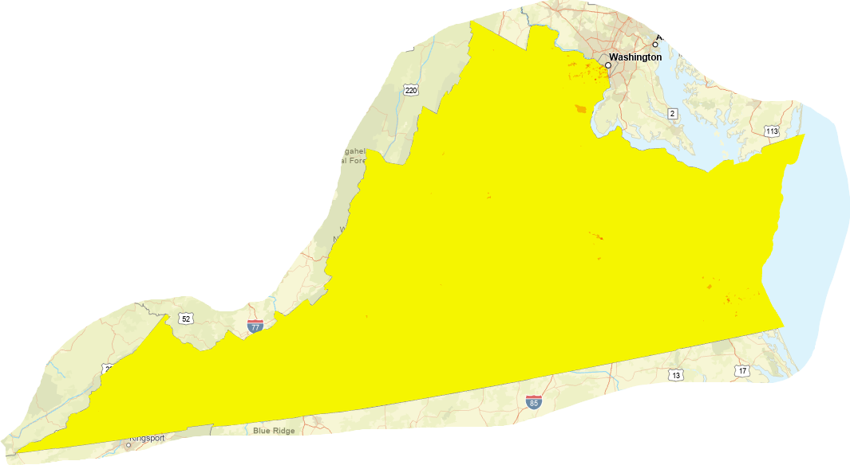

Figure 2. Most bzones (in yellow, representing 93% of the state) have free parking.

Scrap Material

- Develop “InitialParking” based on master block groups
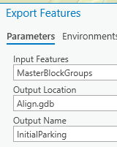

- I did not like the spatial join which created “Parking”
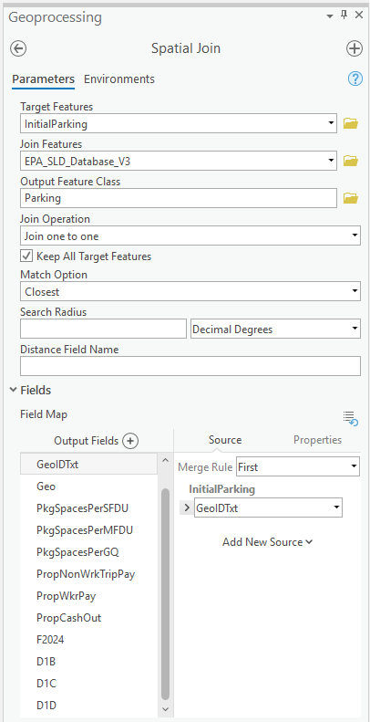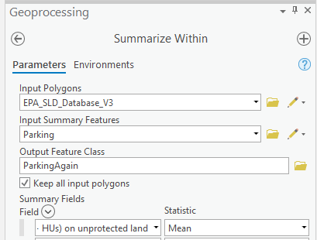

- I did not like the summarize within which created “ParkingAgain”

- Instead I did spatial join to create “ParkingRedone” but used closest and then largest overlap rather than mean. I still did not like that.

- I reprojected everything and then did spatial join with overlap and that does the trick. Those are shown on the last page.

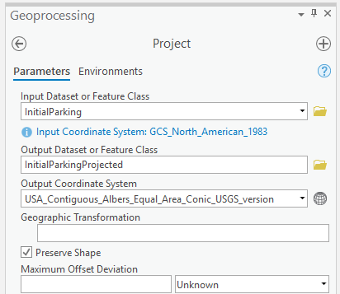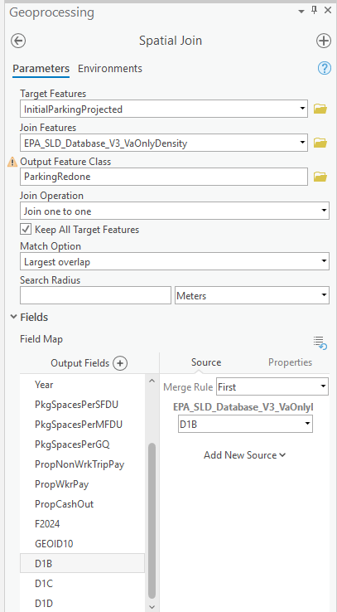

$100 monthly parking Virginia Beach Oceanfront from Parking in Virginia Beach - The Complete Guide

